Mod-4 Journal: Explore Data Structures
Mary Gerdes
CS 500: Introduction to Programming
Southern New Hampshire University
February 27, 2026
Mr. Omar Hamdy

Mod-4 Journal: Explore Data Structures

Introduction
A fundamental part of efficient software development is data structures, and in Python, lists, tuples, and dictionaries are essential tools for organizing and managing data. These structures are important for practical systems where scalability, readability, and performance influence the software quality. To explain in depth, the concept of a shopping cart application is used, where each data structure serves a distinct and strategic role, highlighting its functionality, along with its strengths, limitations, and implementation challenges.

Application of Lists, Tuples, and Dictionaries
In a shopping cart system, lists are mostly used for storing collections of items selected by a user. As products are added and removed, the cart naturally grows and changes, making lists ideal due to their mutability and dynamic resizing. Python lists have built-in methods such as ‘append(),’ ’remove(),’ and iteration, enabling efficient management of cart contents(Python Software Foundation, 2025). Since lists preserve insertion order, they reflect the sequence in which users add items. However, performance can be affected as a cart grows since searching through lists uses linear time complexity (O(n)).
In contrast, tuples are immutable and are used for fixed data within the shopping cart system. As an example, warehouse coordinates, creation timestamps, and product identifiers(SKUs) should remain constant throughout a transaction. Structural integrity is maintained with tuples since their contents cannot be modified after creation. This immutability reduces the risk of accidental changes and makes tuples slightly more memory efficient than lists. Also, tuples are hashable, meaning they can serve as dictionary keys when necessary. However, they are unsuitable for data that changes frequently, such as item quantities or dynamic pricing, since they are so rigid.
The most powerful and practical data structure for a shopping cart application is dictionaries. They are ideal for representing individual products using data stored as key-value pairs. A product dictionary might include keys such as “name,” ‘price,” and “quantity.” Readability and maintainability are enhanced in this structure because values are accessed using descriptive keys rather than numeric indices. Dictionaries also provide average constant-time complexity (O(1)), which improves performance when retrieving or updating product details(Python Software Foundation, 2025).
In practical implementation, a shopping cart application might look conceptually like this:
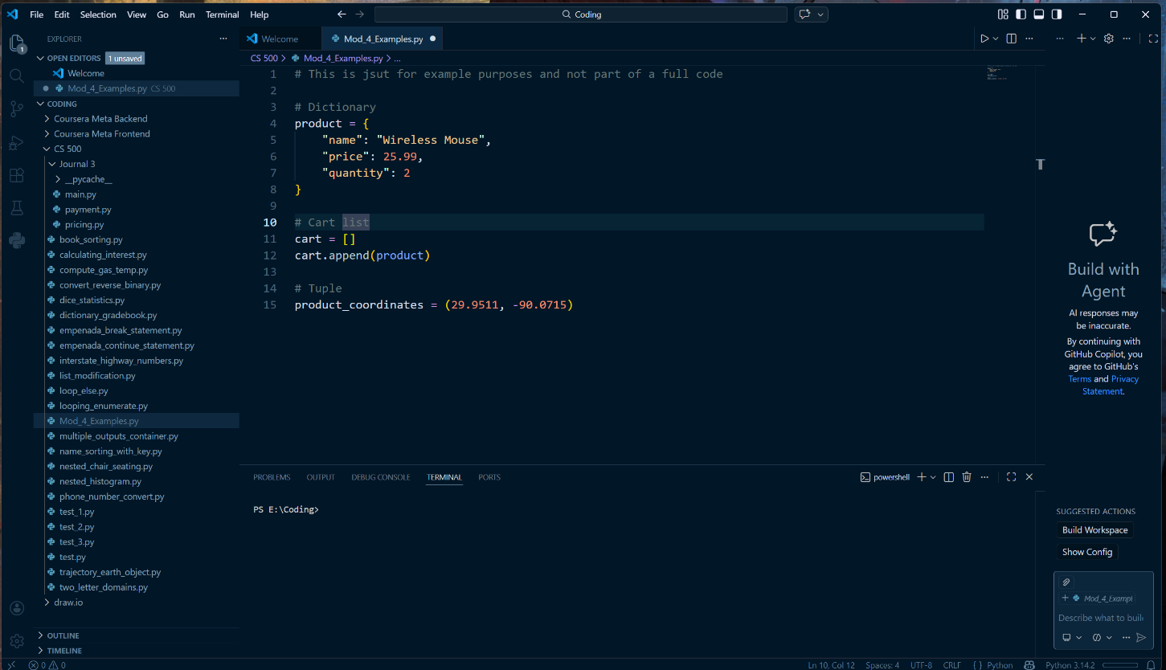
Mod 4 shopping cart example

Advantages and Disadvantages of Each Data Structure
Each data structure offers distinct benefits and trade-offs within the context of a shopping cart application.
For lists, the primary advantage is flexibility and ease of modification. They support dynamic resizing and allow items to be added, removed, or reordered easily, mirroring real-world cart behavior. They are intuitive to use and integrate seamlessly with loops for calculations such as subtotal and total pricing. However, readability and search become inefficient when relying on positional indexing, and clarity is especially reduced when complex nested lists are used.
Tuples, on the other hand, provide stability and predictability. Data integrity is strengthened with their immutability, which also prevents unintended modification of critical product attributes. They are also more memory-efficient than lists and are suitable for fixed data. Their inflexibility is also a disadvantage, as updating tuple content requires creating a new tuple, which can complicate modifying system requirements.
Dictionaries excel in clarity, organization, and performance. Readability and support for rapid data access are enhanced with their key-value structure. They also scale well in systems handling numerous products. However, they consume more memory due to their hash table implementation. They are also vulnerable to retime errors, such as ‘KeyError’ if a key is misspelled or inconsistently named, requiring careful validation and the use of standardized naming conventions.

Challenges in Applying Each Data Structure
Several challenges arise when applying these data structures. With lists, managing duplicate items requires deliberate logic. Developers must decide whether to append a new entry or update an existing quantity, which introduces conditional complexity. Performance concerns also emerge if frequent searches are required.
Tuples have challenges when business requirements change. If additional product attributes become necessary, developers may need to redesign tuple structures, reducing adaptability. While beneficial for security, their immutability limits flexibility in evolving systems.
Dictionaries introduce challenges related to consistency and maintainability. Inconsistent key naming or improper nesting can lead to errors that are hard to diagnose. Ensuring that product data is validated and structured clearly is essential to prevent deeply nested, unreadable code.
The most significant challenge for developers, though, is architectural decision making. Overuse of one data structure can reduce efficiency and clarity. Each structure needs to be selected deliberately based on performance, mutability, and scalability considerations.

Conclusion
Lists, tuples, and dictionaries each play a complementary role. Lists manage dynamic collections, tuples protect immutable data, and dictionaries organize product information, as explained with the shopping cart application. While each structure has limitations, its thoughtful integration results in a scalable, maintainable, and efficient application. By mastering these tools, developers can strengthen their analytical thinking skills in preparation for advanced programming concepts such as object-oriented design and API integration.
References
Python Software Foundation. (2025). 5. Data Structures — Python 3.8.3 documentation. Docs.python.org. https://docs.python.org/3/tutorial/datastructures.html

References

